**Sensor Characterization**

This is a summary of the sensor designs and their performance

Design #1

**Simple Inverting Amp**

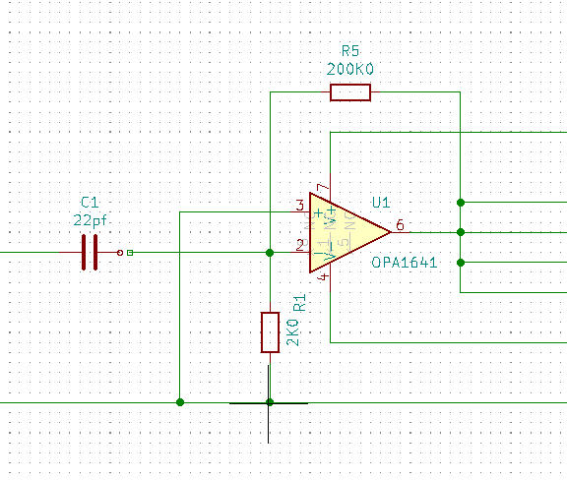

Figure 1: Simple Inverting Amp

This was the design used in Version 1.0X. The signal from the microphone is negative going on the leading edge, hence an inversion was done to flip the signal over and make it useable for the comparator on the circuit board.

Performance of this circuit was good, but very sensitive. Opening the air cylinder at 6 meters would trigger a detection. Moving the mouse on a table nearby would also generate a trip. Clearly too sensitive.

Design #2

**Classical Inverting Amplifier**

The pull down resistor was moved to be a series resistor, and set to 0Ohms. The 2K pull up resistor attached to the microphone acts as the current limit for the amplifier feedback

No apparent change in the sensitivity. Pulling trigger (click) would be detected at 6m.

Design #3

**Feedback set to 47K0 Ohms**

Does not detect trigger click at 6m, but does detect snapped fingers at about 1/2m

Does not detect mouse clicks on the table.

Setting threshold to 1V, all sensors detect snapped fingers.

Picks up the sound of the air rifle at 6m

Design #4

**Feedback set to 10K0 Ohms**

Does not trigger with air rifle discharge,

Will trigger with snapped fingers

Good response. Figure 1 shows recording as pellets passed microphones

The pellet broke a sensor that was located 1.25” ahead of the microphones and started the recording. One hundred fifty (150) microseconds later, corresponding to the pellet moving at approximately 550fps, the sound starts to be picked up at the microphone. The wave rises rapidly and then decays into an echo.

Setting a trip point of approximately 1Volt should identify the

When two microphones are compared, the roll-up from quiet to signal is different as the microphone is nearer or further from the target. This means that there may be a calibration based on position.



Figure 1: Sensor Detection